## Identifying Lost Children using Deep Learning

**B.E. Project Report**

Submitted in partial fulfillment of the requirements For the degree of

### Bachelor of Engineering in

**Computer Engineering**

Submitted by

### Ms. Amisha Mangesh Pupala 18CE5004 Ms. Samruddhi Manohar Mokal 18CE5007 Ms. Neha Ananta Pandit 18CE5022

Guided by

### ( Mrs. Smita Bharne)



Department of Computer Engineering Ramrao Adik Institute Of Technology

Dr. D. Y. Patil Vidyanagar, Sector-7, Nerul, Navi Mumbai-400706. (Affiliated to University of Mumbai)

#### December 2020

**Ramrao Adik Institute of Technology**

(Affiliated to the University of Mumbai)

Dr. D. Y. Patil Vidyanagar, Sector-7, Nerul, Navi Mumbai-400706.

## CERTIFICATE

*This is to certify that, the project ’A’ titled*

### “ Identifying Lost Children Using Deep Learning”

*is a bonafide work done by*

### Ms. Amisha Mangesh Pupala 18CE5004 Ms. Samruddhi Manohar Mokal 18CE5007

**Ms. Neha Ananta Pandit 18CE5022**

*and is submitted in the partial fulfillment of the requirement for the degree of*

#### Bachelor of Engineering

in

#### Computer Engineering

to the

#### University of Mumbai



Supervisor

**(Mrs. Smita Bharne)**

|  |  |  |  |  |
| --- | --- | --- | --- | --- |
| Project Co-ordinator |  | Head of Department |  | Principal |
| **(Mrs. Smita Bharne)** |  | **(Dr. Leena Ragha)** |  | **(Dr. Mukesh D. Patil )** |

Project Report Approval for B.E

This is to certify that the project ‘A’ entitled ***“ Identifying Lost Children Using Deep Learn- ing ”*** is a bonafide work done by ***Ms. Amisha Mangesh Pupala***, ***Ms. Samruddhi Manohar Mokal***, and ***Ms. Neha Ananta Pandit*** under the supervision of ***Mr. Smita Bhare***. This dis- sertation has been approved for the award of ***Bachelor’s Degree in Computer Engineering, University of Mumbai***.

Examiners :

1. . . . . . . . . . . . . . . . . . . . . . . . . . . . . . .

2. . . . . . . . . . . . . . . . . . . . . . . . . . . . . . .

Supervisors :

1. . . . . . . . . . . . . . . . . . . . . . . . . . . . . . .

2. . . . . . . . . . . . . . . . . . . . . . . . . . . . . . .

Principal :

. . . . . . . . . . . . . . . . . . . . . . . . . . . . . .

Date : 16/12/2020

Place : Nerul, Navi Mumbai

Declaration

We declare that this written submission represents my ideas in my own words and where other’s ideas or words have been included, we have adequately cited and referenced the original sources. We also declare that I have adhered to all principles of academic honesty and integrity and have not misrepresented or fabricated or falsified any idea/data/fact/source in my submis- sion. We understand that any violation of the above will be cause for disciplinary action by the Institute and can also evoke penal action from the sources which have thus not been properly cited or from whom proper permission has not been taken when needed.

|  |  |  |
| --- | --- | --- |
| **Ms. Amisha Mangesh Pupala** | **18CE5004** |  |
| **Ms. Samruddhi Manohar Mokal** | **18CE5007** |  |
| **Ms. Neha Ananta Pandit** | **18CE5022** |  |

Date : 16/12/2020

# Abstract

A countless number of children go missing in India every year. And a large number of children remain untraced due to the problem in the identification of children using the photograph. As the state-of-the-art missing children identification systems using face recognition fall short in identifying children at later stages because of aging. We have proposed a novel use of face recognition with face aging to overcome the limitation of existing systems. We have proposed a solution using deep learning, in which we have created a virtual space where the public can upload images of missing children and can also search for a lost child. We have used the Age C-GAN algorithm for face aging and the FaceNet algorithm for face feature extraction and face recognition.

# Contents

|  |  |
| --- | --- |
| **Abstract**  **List of Figures List of Tables**  **1 Introduction** | **i iv v**  **1** |
| 1.1 Overview . . . . . . . . . . . . . . . . . . . . . . . . . . . . . . . . . . . . . | 2 |
| 1.2 Objective . . . . . . . . . . . . . . . . . . . . . . . . . . . . . . . . . . . . . | 2 |
| 1.3 Motivation . . . . . . . . . . . . . . . . . . . . . . . . . . . . . . . . . . . . . | 3 |
| 1.4 Organization of report . . . . . . . . . . . . . . . . . . . . . . . . . . . . . . . | 3 |
| **2 Literature Survey** | **4** |
| 2.1 Survey of Existing System . . . . . . . . . . . . . . . . . . . . . . . . . . . . | 4 |
| 2.2 Limitations of Existing System . . . . . . . . . . . . . . . . . . . . . . . . . | 6 |
| 2.3 Problem Statement . . . . . . . . . . . . . . . . . . . . . . . . . . . . . . . . | 7 |
| 2.4 Scope . . . . . . . . . . . . . . . . . . . . . . . . . . . . . . . . . . . . . . . | 7 |
| **3 Project Proposal** | **8** |
| 3.1 Proposed Work . . . . . . . . . . . . . . . . . . . . . . . . . . . . . . . . . . | 8 |
| 3.2 Proposed Methodology . . . . . . . . . . . . . . . . . . . . . . . . . . . . . . | 10 |
| 3.2.1 Age-cGAN: . . . . . . . . . . . . . . . . . . . . . . . . . . . . . . . . | 10 |
| 3.2.2 FaceNet: . . . . . . . . . . . . . . . . . . . . . . . . . . . . . . . . . | 11 |
| 3.2.3 FG-NET Dataset: . . . . . . . . . . . . . . . . . . . . . . . . . . . . . | 12 |
| 3.3 Details of Hardware/Software Requirement . . . . . . . . . . . . . . . . . . . | 13 |
| **4 Planning And Formulation** | **14** |
| 4.1 Schedule for Project . . . . . . . . . . . . . . . . . . . . . . . . . . . . . . . . | 14 |

4.2 Detail Plan of Execution 16

|  |  |  |  |
| --- | --- | --- | --- |
| **5 Design of System** | |  | **17** |
| 5.1 Design Diagram with Explanation | | . . . . . . . . . . . . . . . . . . . . . . . . | 17 |
| **6** | **Expected Results** | | **20** |
|  | 6.1 Implementation Details . . . . . . . . . . . . . . . . . . . . . . . . . . . . . . | | 20 |
|  | 6.2 Project Outcomes . . . . . . . . . . . . . . . . . . . . . . . . . . . . . . . . . | | 22 |
| **7** | **Conclusion and Future Work** | | **29** |
|  | 7.0.1 Conclusion . . . . . . . . . . . . . . . . . . . . . . . . . . . . . . . . | | 29 |
|  | 7.0.2 Future Work . . . . . . . . . . . . . . . . . . . . . . . . . . . . . . . | | 29 |

##### References 31

Appendices 33

1. Weekly Progress Report Project A 33
2. Plagiarism Report 34

Acknowledgement 35

**List of Figures**

**Figure 1** Layers used in Aging cGAN. 07

**Figure 2** Face Aging Method 08

**Figure 3** Model architecture of FaceNet. 10

**Figure 4** Sample images from FG-NET face dataset. 10

**Figure 5** System Design for lost child identification. 16

# List of Tables

**Table 1** Literature Survey of Existing System. 5

# Chapter 1 Introduction

Children represent a significant percentage of the total population of India. Unfortunately, many children go missing every year due to various reasons like kidnapping, trafficked children and lost children, run-away children, and abduction. According To the National Crime Record Bureau 2019 report, the number of missing children has increased by 8.9% since 2019 giving a total of 73,137 children reported missing last year. Many NGOs claim that the actual number of missing children cases is much more than reported. A child lost in one location can be found in some other location. Even if the child is found it gets difficult to recognize him/her. The Face recognition is thus the most promising biometric technology for recognizing missing children. But if the child is found after many years from the date when he/she is lost the state-of-art face recognition systems fall short to identify children from the photograph because a child's face undergoes many temporal variations due to aging like a change in skin texture, change in the shape of the face, color, weight, facial hair growth, etc. Hence as the time difference between a probe image and a true mate image gets larger, the performance of the face recognition algorithm decrease, and thus the search gets harder. Thus the primary goal of the proposed system is to generate an age-progressed image of the child rather than enhancing the face recognition performance. Thus this system enhances the ability of face matches to identify and locate children who are lost at a young age by aging face features to reunite them back with their families. Our system will be helpful to the police and higher authorities for tracking down missing children quickly.

### Overview

As children’s are the important aspect of our country, but due to cases of missing children’s arising it is becoming like a threat to the future of our country. And finding any missing child with one photograph is a difficult job for the officials, as recognition plays a vital role in solving the case of missing children. And when the barriers come in the part of the recognition it becomes very difficult to solve the case and find the children who is missing, which can take 5 t0 10 years and that’s why many children’s are interested till date which is becoming the main reason into the increasing cases of the missing children. Sometimes it takes 5 to 10 years to solve case so the aging also becomes barrier in the recognition and then it becomes more difficult to recognize the children from the photograph which was given at the time of reporting, So the aging also plays an important role in the recognition and then it becomes more difficult to recognize the children from the photograph which was given at the time of reporting, So the aging also plays an important role in the recognition. Our system overcomes all these barriers which create difficulties in the recognition part. Using the deep learning features like FaceNet algorithm for recognizing any children using the aging feature (C-gan) can solve the issues and the process can go smoothly which will be very helpful for solving the cases.

### Objective

Recognizing a missing child is a difficult job for the police and also for the higher authority, and even if a child is found, it becomes difficult to recognize him/her from the reported missing cases which include the photograph. Recognizing or identifying a child using face detection will make the process much easier. The proposed idea is based on the maintaining database, such that at the time of the reporting photograph (recent photographs) of the missing child which is given by the parents will get stored and the provision will be given to the public to voluntarily take the photographs of the children so they can add the photograph to the portal, so the automatic searching will take place. So, the objective of this project is to help Police and higher authorities track down missing children quickly.

### Motivation

* + - Children are an important factor in our society, after all, they are the future which we look up to.
    - But many children are get reported missing every year, which creates a big issue as most of them are interested.
    - This problem arises because of the difficulties that come with the identification of the missing child. It is needed to solve this problem so these missing children can have a better future and to reduce the number of cases that are increasing day by day.

### Organization of report

The report is organized by considering the topics as Literature Survey, Proposed Work, Results and Analysis, Conclusion and Future Works. Where the literature survey is consisting of the survey we have gone through, for example, the papers that we have used for our survey which have helped us to understand the condition and also the design of our system. Whereas the actual work and the methodologies are the algorithms we have used for our system is con- sisting of the topics as proposed work which have the details of the algorithm with the working of it and the software used for the implementation, fulfilled with the whole implementation details. The actual working means how the system will actually work in real life and imple- mentation of the system is shown in the result and analysis with the actual pictures (snapshots) of the system which has been implemented. And the last is the conclusion of the project ”Lost Children Identification using Deep Learning” with the future work which is given in detail that we can do further improvement in the system and the implementation which we can carry out in future so it will be more beneficial.

# Chapter 2 Literature Survey

### Survey of Existing System

|  |  |  |  |  |
| --- | --- | --- | --- | --- |
| NAME OF THE  PAPER | NAME Of THE  TECHNOLOGY | INTRODUCTION | ADVANTAGES | DISADVANTAGES |
| 1) Missing Child Identification System Using  Deep Learning and Multiclass SVM | CONVOLUTIO- NAL NEURAL NETWORKS (CNN)  VGG-FACE CNN DESCRIPTOR | CNNs are essential  tools for deep  learning methods and are more appropriate for  working with image data. CNNs or  ConvNets are composed of  series of interconnected layers and these  layers consist of repeated blocks of convolutional,  ReLU pooling  layers and fully connected layers.  VGG-Face network is used for face recognition. | Performance these technologies is tested using  the photographs of children with different lighting  conditions, noises and also images at different ages of  children. The Classification achieved a  higher accuracy of  99.41 | This technologies involves complex algorithms which make the process  of extraction and classification slower. |

|  |  |  |  |  |
| --- | --- | --- | --- | --- |
| 2) Double-Blinded Finder: A Two- Side Privacy-  Preserving Approach for Finding  Missing Children | MULTITASK FACENET MODEL AND IPE METHOD FOR BLIND FACE MATCHING | Face-to-face matching can be safely  run on the public cloud due to the face  matching method  based on IPE- based blind computing to  restrict access to photos | Using these  technologies, the system can achieve practical performance of  blind face matching  with negligible privacy leakage  of both the suspicious and true missing  children sides | solutions, especially internal products with  threshold encryption schemes, should be improved to  accommodate more effective face recognition  applications in a secure environment |
| 3) Child Face Recognition with Deep Learning. | VGG16, RESNET50, MOBILE- FACENET | In this  paper, three  Convolutional Neural Networks (VGG16,ResNet50  and Mobile- FaceNet)  were proposed.  MobileFaceNet is a lightweight model compared to  other two models | Among three proposed CNN  methods Mobile- FaceNet gives higher accuracy  than others and processing time is faster  than other two. | VGG16 requires largest model  size and MobileFaceNet is a smallest  model size. |
| 4)Optimizing deep neural network structure for  face Recognition | DEEPID MODULES WITH WIDE MODULE. | In this paper, DeepId, FaceNet  networks are adjusted by adopting modified  Inception structures which have different branches. | The mutual  information of a single image in the same layer  of different designed networks grows at the  beginning as the width increases. However, the  mutual information decrease with additional branches in wide module. | A deep  face network shows the best performance  when the difference between wide module and deep module  is nearly equal |

**Table 1:** Literature survey of Existing System

* + - Paper[1] uses Convolution Neural Networks and VGG Face descriptors for Face Recog- nition. In this paper, the author mentioned that CNNs are essential tools for deep learning methods and are more appropriate for working with image data. CNN or Conv-Nets are composed of series of interconnected layers and these layers consist of repeated blocks of convolutional, ReLU (rectified linear units), pooling layers, and fully connected layers.

These learned features were used to train a multi-class SVM classifier. They used this method to correctly identify and label the kid.

* + - Paper[2] applies IPE-based blind computing to restrict access to Images on Multitask FaceNet Model. It used the MT-FaceNet model to describe a child’s face as a 128d fixed-point feature vector as well as auxiliary attributes. In this system, Face-to-face matching can be safely run on the public cloud due to the face matching method based on IPE-based blind computing. Using these technologies, the system can achieve a practical performance of blind face matching with negligible privacy leakage of both the suspicious and true missing children sides.
    - Paper[3] uses three Convolutional Neural Networks (VGG16, ResNet50, and Mobile- FaceNet) were proposed. MobileFaceNet is a lightweight model compared to the other two models. It works efficiently and fast on embedded devices because of its depth- wise separable convolutional layers. Among the three proposed CNN methods, Mobile- FaceNet gives higher accuracy than others and the processing time is faster than the other two.
    - Paper[4] uses DeepId, FaceNet networks are adjusted by adopting modified Inception structures which have different branches. Among these, A deep face network shows the best performance when the difference between the wide module and deep module is nearly equal.

### Limitations of Existing System

* It is been noted that the Existing systems do not contain an Age-progression module that helps recognize any child with an age gap of 3-5 years. So if any missing child is found after 3-5 years the child cannot be recognized by the face recognition algorithm correctly.
* The existing system does not give high accuracy for images clicked in an uncontrolled environment containing low light, blur images, images which are taken from a distance, changes of the pose, illumination, and expression, etc.
* Existing system uses complex algorithms which makes the system more complex and the system slower.

### Problem Statement

India is one of the countries that control a fifty fifth of the population of youth and kids. And this fifty-fifth is taken into account because the vital facet of our country, however, several ranges of kids are getting rumored missing each year that creates a giant issue as most of them are interested. This downside arises as a result of the difficulties that come with the identification of the missing kid. However, this downside may be solved using a system that is predicated on the deep learning methodology for the identifying of the reported missing child from the photos with face recognition. Because the missing kid may be found in any region, thus with the landmarks and remarks public will upload the photograph of the suspicious kid into the common portal. Automatic comparison can present itself with the photo that the public has posted and therefore the registered photo of the missing kid from the repository. A deep learning model is trained as there is going to be a method of classification for the input photo of the kid and therefore the photo that is matching best can get selected from the information of the missing children. To help the authorities in the cases of the missing children which will be beneficial for our society.

### Scope

Missing children cases are arising day by day because of the problem in the identification, and this problem arises because it is difficult to find a child with a photograph with hundred percent surety and when the time goes by like after 5 to 0 years the problem of age gap creates more difficulties in the identification and after 5 or 10 years later identifying a child with an old photograph is much harder than we think. And police officers and other higher authorities have to go through these difficulties and more importantly the missing child and his/her parents have to face all these difficulties. So, by observing such conditions our system will not only help in the identification but even after 5 or 10 years later if any suspected child gets found the system will recognize the child correctly with the feature of an age gap and deep learning. Therefore, it will be much easier for the police officer and the parents of the missing child to identify the missing child quickly and easily, it will help the process go smoothly and perfectly.

# Chapter 3 Project Proposal

### Proposed Work

It is known that the performance of the face recognition algorithm is affected due to aging. It is still a problem to consider the aging parameter under consideration for face recognition as most of the algorithm fails to detect the face of the child after a few years.

A child’s face undergoes various changes including facial hair, weight, the texture of the skin, shape, and size of the face, etc. Several studies were performed to analyze the extent to which facial aging affects the performance of face recognition algorithms. Two conclusions can be drawn from these studies:

* + 1. The performance of traditional face recognition algorithms decreases with an increase in time-lapse.
    2. Performance of face recognition and detection algorithms decreases more rapidly in the case of younger individuals as compared to older individuals.

Hence it is important to consider the age progression of the face for enhancing the performance of the face recognition algorithm, especially when enrolled at a young age.

In particular, our contributions are as follows:

* A portal for finding missing children that compare the image of the missing child with the images of the already registered missing children.
* To take into consideration many kinds of variations in face images which are taken un- der uncontrolled conditions such as change of expression,, illumination, pose, change in lighting condition, presence of noise and blurred image.
* Using Age Conditional Generative Adversarial Network to reconstruct high-quality synthetic images of the required age group preserving the original person’s identity. Using methodology like Facenet and C-Gan the process of recognition gets easier which will help the authorities to find the missing children quickly and solve many cases which have been untraceable because of the above issues.

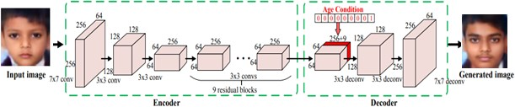

**Figure 1:** Layers used in Aging cGAN

**Here we propose a methodology for missing child identification and recognition to make the process of finding a missing child less painful and faster. As compared to the existing system we are solving the problem of face variations caused due to the age gap by combining facial feature extraction and age progression based on deep Learning.**

**ABSTRACT**

Thus the proposed system presents a novel deep learning methodology to find the missing children using the photo of the children currently available using face recognition. Whenever anyone finds any suspicious child on the road he/she can click the photograph of the child and upload it into the common portal with landmarks and remarks. The public can upload the photograph of the missing child into the portal. Then the photo will automatically be compared with the already registered images in the repository. If no matching record is found then the image will be age progressed and again the age-progressed image will be compared with the registered photos. For this, a deep learning model Aging C-GAN is used. And the face recognition is done using FaceNet. Thus the proposed system outperforms the earlier methods in face recognition based on missing child identification.

As mentioned earlier face aging model is based on an age-conditional generative adversarial network, a model for synthesis and generation of human faces of the required age category.

Thus the task of our cGAN network is to generate the image of a child at different ages based on the input image and target age. The structure of the model consists of three parts: encoder, age condition, and decoder. The encoder is used for feature extraction of the input face image. We are using three groups of convolution layer and nine residual blocks. Each convolution layer consists of a ReLU non-linearity layer, spatial batch normalization layer stride, and a convolution layer. After this, we get a 56 feature map of the image. Since there is a huge range of images of a large number of age groups in our dataset we are dividing the image into y number of groups which is represented as a one-hot age vector. Each block represents a specific age group. The task of the decoder is to convert the face to generate an image of the required age group based on the features.

### Proposed Methodology

#### Age-cGAN:

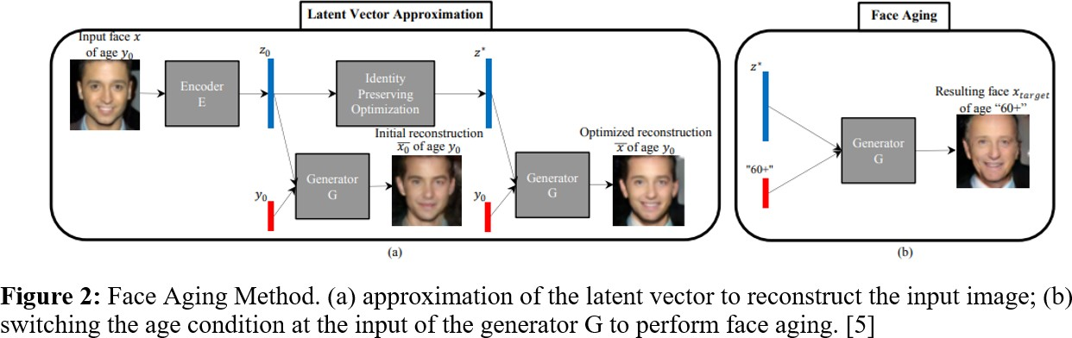

**Conditional Generative Adversarial Network is conditioned on extra information and is based on the idea of Vanilla GAN which allows us to control the output of the generator network. In this, we have to give extra information y as an additional layer to the generator. As compared to vanilla GAN, In vanilla GANs we cannot control the category of the retrieved images as it can learn only one category, however, in CGAN we can generate images of the specific category using condition y. y can we any data depending on the application for which we are building the model for like integer data or class label. Thus CGAN can be used to generate models with different categories and conditions.**

##### 

##### The Face Aging-cGAN has four networks:

**Encoder: Encoder is a deep convolution neural network used to generate the latent vector of images.**It is used to learn the inverse mapping of input image and age condition with the latent vector Z.

• It generates a latent vector of 100 dimensions of the input face images of dimension(64,64,3).

• There are 2 dense layers and 4 convolution blocks.

• All the convolution blocks except the first layer have a convolution layer which is followed by a batch normalization layer and then an activation function.

**Generator Network:**It is a deep convolutional network that takes a face image and condition vector and tries to generate realistic images of the face.

• It is a CNN having upsampling, convolutional, and dense layers which take a condition vector which is additional information added to the network which is age, and a latent vector to generate a realistic image of a dimension of (64, 64, 3). The condition vector is the additional information that is provided to the network. For the Age-cGAN, this will be the age.

**Discriminator Network:**It is CNN that is used to discriminate between the real image and the fake image. It contains several convolutional blocks which contain a batch normalization layer, convolutional layer, and an activation function.

**FaceNet:**It is a face recognition model that learns the difference between the original image x(input image) and the generated image x’. it is used to recognize the person's identity in the image. We are using a ResNet2

For FaceNet Inception ResNet, ResNet-50, or pre-trained Inception can be used. We are using the ResNet2 model without fully connected layers. FaceNet is used to identify the person’s identity in the given input image. The extracted embeddings for the original input image and the reconstructed image can be found by calculated Euclidean distance between the embeddings.

# Stages of the Age-cGAN

Age-cGAN has four networks and it is trained in three stages:

1.    **Conditional GAN training:** In this stage, we have trained the generator network which generates the blurred images of the face after training and the discriminator network.

2.    **Initial latent vector approximation:** In this stage, we have trained the encoder network to approximate the latent vector using both the real images and the generated images which generates the latent vector from learned distribution.

3.    **Latent vector optimization:** In this stage, we have optimized both the encoder and the generator network.

#### 3.2.1 FaceNet:

#### 

We are using FaceNet in our work for feature extraction and face recognition. We have first passed all the images through Multi-Task Cascaded Convolutional Neural Network (MTCNN) for finding and extracting faces from the images. Then we have used FaceNet for extracting high-quality features from children's faces which we have used to train a face identification system. It uses Convolution layers to learn embeddings from the face directly which are used for face verification and face recognition. These embeddings are of 128 dimensions and insert them into feature space such that the squared distance between faces of the same person is less whereas the squared distance between images to two different people is large.

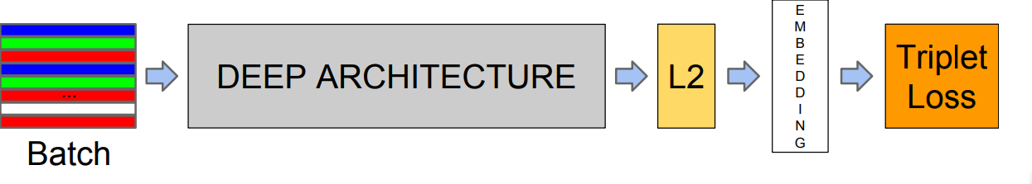

**Figure 3:** Model architecture of FaceNet.

#### Dataset:

We have used two separate datasets for the training of face recognition and the Age Progression model. For face recognition, we have created our dataset by collecting images of children from various sources. We have created a directory structure where each child to be recognized is having a dedicated directory with their images saved in it. The photos in the directory provide a range of orientation, sizes, lighting conditions. If an image contains multiple faces then the face having the highest probability will be considered for further steps. We are using this dataset as the basis for our classifier which is trained on a training dataset only.

For training the Age progression model we have used the IMDB WIKI-crop dataset which is the largest publically available dataset of human faces. It contains about 400 thousand images where each image is labeled in the format gender_age_name with all the metadata information like dob, the year when the photo was taken, gender, face location, face, and secondary face score, etc in .mat file. The dataset contains images of all the age categories from 0 to 100 years of age which is not required for the model. So we have first filtered the dataset and considered the images of children in the age group from 0-15 years of age and have deleted the rest of the images. The dataset contains images with huge variations in facial expression, illumination, resolution, occlusion, pose, etc. The dataset also provides the corresponding landmarks. This dataset can be used for a variety of tasks including age estimation, age progression, landmark localization, progression/ regression, face detection, etc.

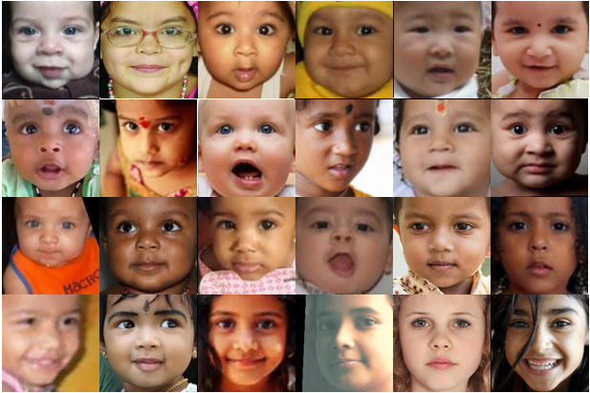

**Figure 4:** Sample images of different individuals from IMDB Wiki-Crop dataset face dataset

### Details of Hardware/Software Requirement

##### python 3.8.5

* **Anaconda v4.8.3**: Conda is an open-source distribution of R and Python programming language for data science and scientific computation which is used to simplify deployment and package management.
* **Jupyter Notebook**: The Jupyter Notebook is an web application which is used to share and create documents containing narrative text, visualization, equations, live code. Uses include machine learning, data visualization, statistical modeling, numerical simulation data cleaning and transformation, and much more.
* **NumPy 1.19.2**: NumPy is a library that is used for working with large, multidimensional matrices arrays.
* **pandas 1.1.3**: pandas is a fast and powerful open-source data manipulation and analysis tool.

##### scikit-image 0.17.2

* **matplotlib 3.3.2**
* **Keras** is written in Python and it is a leading high-level neural network APIs which supports multiple back-end neural network computation.
* **Tensorflow v2.3.1:** TensorFlow is a flexible and comprehensive end-to-end open-source platform for machine learning.

# Chapter 4

**Planning And Formulation**

### Schedule for Project



* 1. **Detail Plan of Execution**
     + **Existing System Study:** At the start of July, We started gathering the research papers that are related to the Lost child identification topic. After going through many research papers, we have done the analysis of papers and Literature survey through which we come to know that there are some limitations present in the existing system.
     + **System Design and Planning:** At the start of August, We started designing our system after analyzing the existing system. To overcome the limitations of the existing system we decided to work on the Aging invariant module in face recognition. After much research, we decided to use a Conditional- Generative Adversarial Network and we decided the further planning of our system.
     + **Gathering System Requirements:** From the middle of August week, we started gather- ing the Child dataset that is required for the system. After testing some child datasets, we start creating our dataset from scratch for more accuracy. For our system as we are going to use Keras and Tensorflow, we started downloading all the important libraries that are required for implementation.
     + **Implementation:** At the start of September, We started the implementation process of our system. We started implementing the Face recognition module. First, we loaded the dataset that we created from scratch into the Jupyter notebook that we created from scratch. After that, we started implementing the module which extracts the faces of chil- dren from images and labels them, and stored them in a different folder. After completing the Extracting face module, we started to generate embeddings of images and after that, we started work on face recognition. After completing the face recognition module we started testing. At the start of testing, we got many errors and false predictions but after training the dataset we got accurate predictions for each image. At end of November, we started implementing the Aging invariant module.

# Chapter 5 Design of System

### 5.1 Design Diagram with Explanation

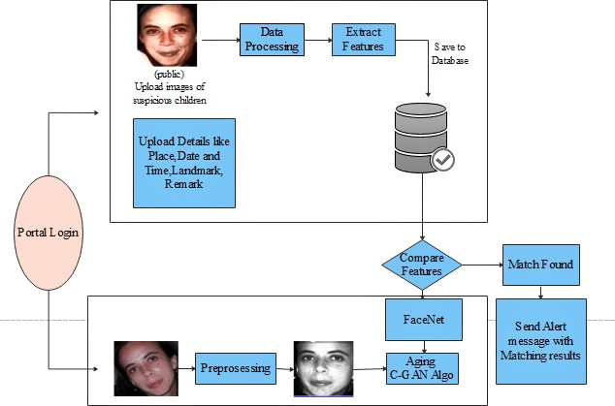

**Figure 5:** System design for lost child identification using FaceNet and C-GAN

The proposed system consists of a portal where the public can store the details with a photograph of the missing child. The public here refers to the parent of the missing child or the police officer. By using the photograph the public can find the matching children from the already stored data. The system will prompt the most matching cases after applying a face recognition algorithm to the uploaded image. Once the matching is done then the concerned person will get the details of the child.

The proposed model is divided into various phases. First, whenever the public finds any missing or suspicious child they can upload the photograph of the child with the details like name of the child, age, place where the child was found, date and time when the child was found and remarks like what clothes the child was wearing when he was spotted or any information the child might have told to the person which can be helpful to find the child.

This uploaded image goes through an image pre-processing phase. The input to this is the raw image that is uploaded by the public and the output of this phase is an aligned frontal face image. The main purpose of this step is to align all the face images based on eye coordinates such that all the images are aligned with the same standard size.

The next stage is to extract the required face features. In this stage, we have used a Multi-task Cascaded Convolutional Networks (MTCNN) model which is a framework used for face alignment and face detection which consists of three stages of convolutional networks that can detect landmark location such as eyes, nose, and mouth and can recognize face very efficiently. The preprocessing step includes removing noise from the image, straighten the image, and detecting and cropping the face from the whole image. The extracted face features will be stored in the database for further processing.

To search for a missing child parent of the child need to upload a photograph of the child then this image will go through the face recognition algorithm after the image pre-processing and feature extraction step. If any matching photo is found in the database then the image of the child will be displayed on the screen. If no matching image is found then the uploaded image goes through the Age CGAN algorithm. The GAN algorithm is used to generate a new age-progressed image with the same statistics as the training images. As the child may be spotted after many years, the face of the child changes from the last known photograph taken before the child had gone missing.

So this model will be used to synthesis the child's face to produce an age-progressed facial image of the child. So basically this model will be used to synthesis child face to the required age category.

This face synthesized and age-progressed image goes through the FaceNet algorithm for feature extraction and face recognition. The main distinction between FaceNet and other face recognition algorithms is that FaceNet does not use any bottleneck layer for verification and recognition tasks but rather learns the mapping directly from images and creates embedding. The FaceNet is used to automatically compare the age-progressed photo of the missing child with the already present images in the database and if the photo matches with any of the photos present in the database then it will be displayed on the screen along with details like name, location and time where the child was found.

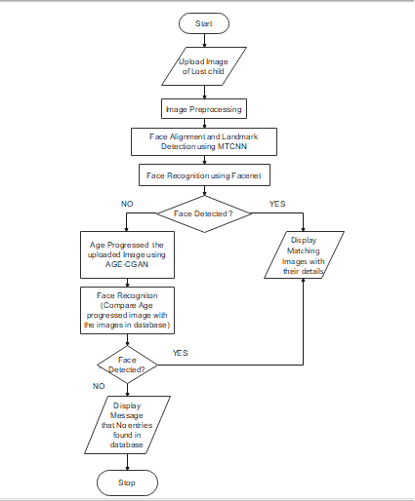

# Chapter 6 Expected Results

### Implementation Details

We started our implementation by creating a Face Recognition module using FaceNet. Face recognition is the process of identifying and verifying the person from images of their faces. First, we created the dataset from scratch containing many photos of children. For implemen- tation, we downloaded all required Libraries that are scikit-image 0.17.2 , matplotlib 3.3.2, NumPy 1.19.2 , pandas 1.1.3, Tensorflow v2.3.1, Keras, and also we downloaded the FaceNet model which is required for Keras. To detect faces for Face recognition we use the Multi-Task Cascaded Convolutional Neural Network or MTCNN.

**Loading the Dataset :** We created a dataset containing many images of children. To train the dataset first we have to load it in a library. After giving the path to a directory of a dataset, each photograph present in the dataset loaded along with the shape of a NumPy array containing face pixel data.

**Detecting and Extracting Faces :** The first step is to detect faces in each photograph present in the dataset and reduce the dataset by placing only the faces of children. The ex- tractface( ) function is to extract the faces from each photograph. Our dataset is consist of 11 children’s photos from extract face function We can detect the face in each photograph, and create a plot with each face, Each face was correctly detected, and that we have a range of lighting, skin tones, and orientations in the detected faces. For extraction of faces, we prepare a dataset with the name as the output label for each detected face. The generatefacesfromimages(

) function loaded all of the faces into a list for a given directory. After calling the generate- facesfromimages( ) function, Each face has one label, the name of the children, which we take

from the directory name loaded. The generatefacesfromimages function detects faces for each subdirectory of children assigning labels to each detected face and stored it in a different di- rectory. We can then call the function for the ’minidataset’ and ’children duplicate’ folders to load all of the data, then save the results in a single compressed NumPy array file via the savezCompressed() function.

After running the extractFace() function, First, all of the photos in the ’minidataset’ dataset are loaded, then faces are extracted, resulting in 14 samples with square face input and a class label string as output. Then the ’children duplicate’ dataset is loaded, providing 13 samples that can be used as a test dataset. Both datasets are then saved to a compressed NumPy array file called faceDatasetNumpy.npz ’ that is about three megabytes and is stored in the current working directory.

**Generating Embedding from faces :** The next step is to create Embeddings from faces. A face embedding is a vector that represents the features extracted from the face. This can then be compared with the vectors generated for other faces. For example, another vector that is close by some measure may be the same person, whereas another vector that is far by some measure may be a different person. The classifier model that we want to develop will take a face embedding as input and predict the identity of the face. The FaceNet model generates this embedding for a given image of a face. We used the FaceNet model to pre-process a face to create a face embedding that can be stored and used as input to our classifier model. We can, therefore, pre-compute the face embeddings for all faces in the ’minidataset’ and children duplicate dataset. After running the getEmbedding() function face dataset was loaded correctly and so was the model. The training dataset was then transformed into 23 face embeddings, each comprised of a 128 element vector. The 23 examples in the ’minidatset’ dataset were also suitably converted to face embeddings. The generated dataset were then saved to a compressed NumPy array with the name ’faceEmbeddings.npz ’ in the current working directory.

**Classification, Normalization, and Prediction :** For Face recognition, first, we have to classify the face embeddings. We have to load the face embeddings to classify. The data require some minor preparation concerning modelling for that we have to normalize the face embedding vectors because the vectors are often compared to each other using a distance metric. Vector normalization means scaling the values until the length or magnitude of the vectors is one of unit length. For Vector normalization, we used the Normalizer class in scikit-learn with the face embeddings. After that string target variables for each child’s name need to be converted to integers for that Labalization is required. For Labelization we used LabelEncoder

class in scikit-learn. The next step is prediction, We have to create the dataset which contains the photographs that we want to predict. After creating the predicted dataset we have generated their embeddings for faces by using the ’faceEmbedding.npz’ file. After that, we have to load any image that we want to predict and after extracting the face from that image it will generate its closed prediction. Every child we want to recognize having their directory with their images in it. The images contain the face of only one person. If the image contains multiple faces, only the one detected with the highest probability will be considered and accordingly, it will generate the given image’s closed prediction.

### Project Outcomes

First load all required libraries.

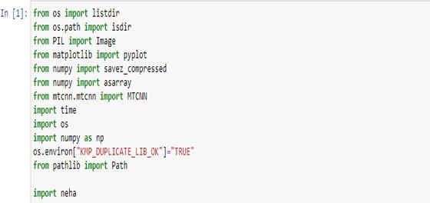

Load the dataset:

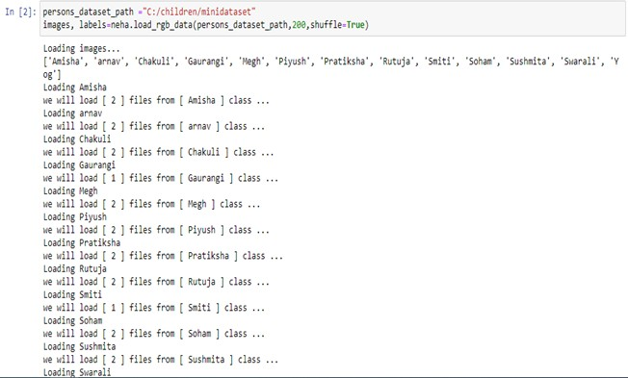

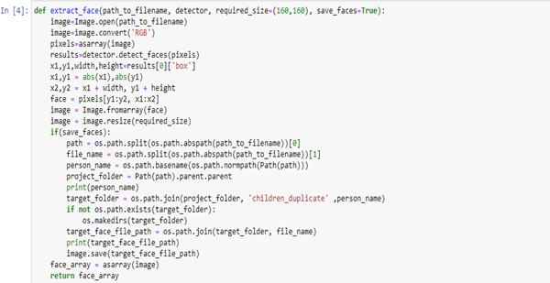Detect the faces from the images present in the dataset and extract faces from images and label each extracting face are done in the extractFace() function.

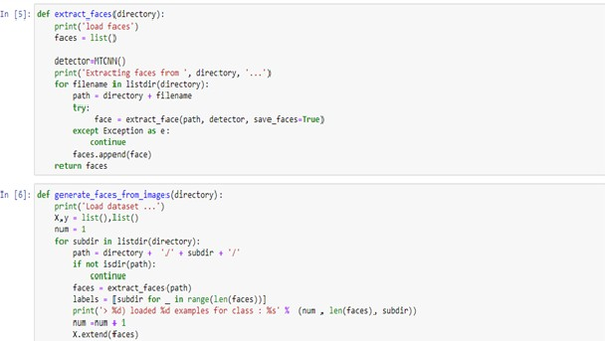

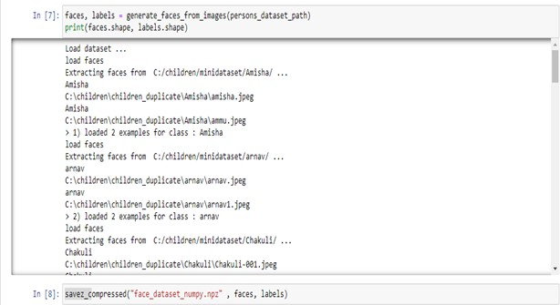All the photos in the ’minidataset’ dataset are loaded, then faces are extracted, resulting in 14 samples with square face input and a class label string as output, and all these labelled extract faces are stored in a different directory called ’Children duplicate’. Then the ’children duplicate’ dataset is loaded, providing 13 samples that can be used as a test dataset. Both datasets are then saved to a compressed NumPy array file called ’faceDatasetNumpy.npz ’ that is about three megabytes and is stored in the current working directory.

After extracting faces from children photos present into ‘minidataset’. Images that are stored

in ‘children duplicate’ directory :

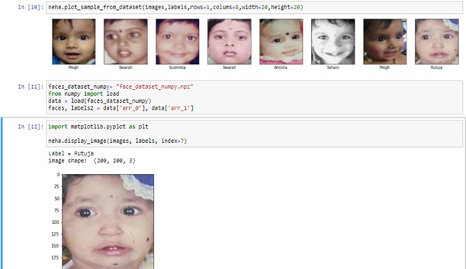

Generating embedding from faces that are stored in a dataset is done using the getEmbed- ding() function. After running the getEmbedding() function face dataset was loaded correctly and so was the model. The training dataset was then transformed into 23 face embeddings, each comprised of a 128 element vector. The 23 examples in the minidatset dataset were also suitably converted to face embeddings. The resulting datasets were then saved to a compressed NumPy array that is about 50 kilobytes with the name ’faceEmbeddings.npz ’ in the current working directory.

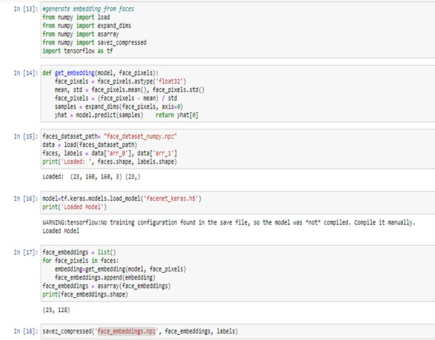

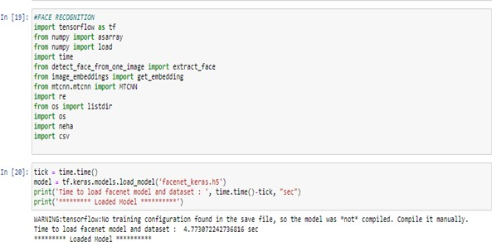For face recognition we import all the required libraries and FaceNet model :

Classification, Normalization, and Prediction :

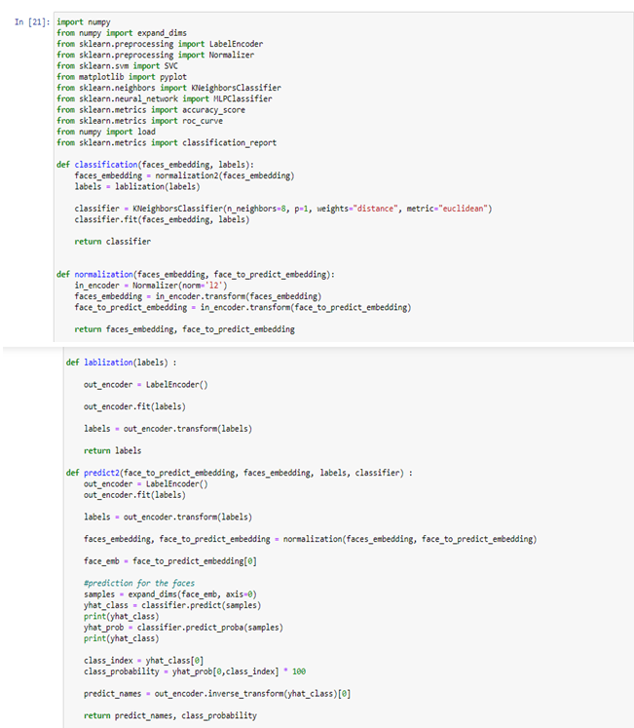

Insert the input image that we want to predict and extract face and generate embeddings of that input image:

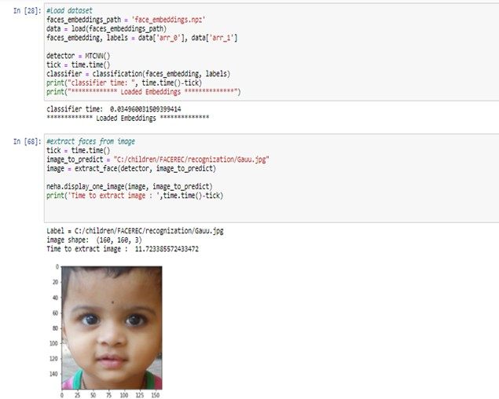

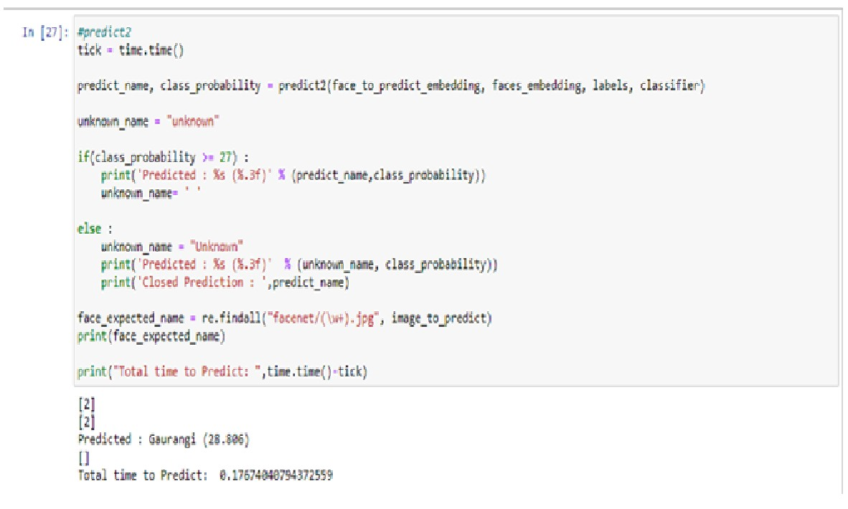Generates its closed Prediction :

**Result and analysis**

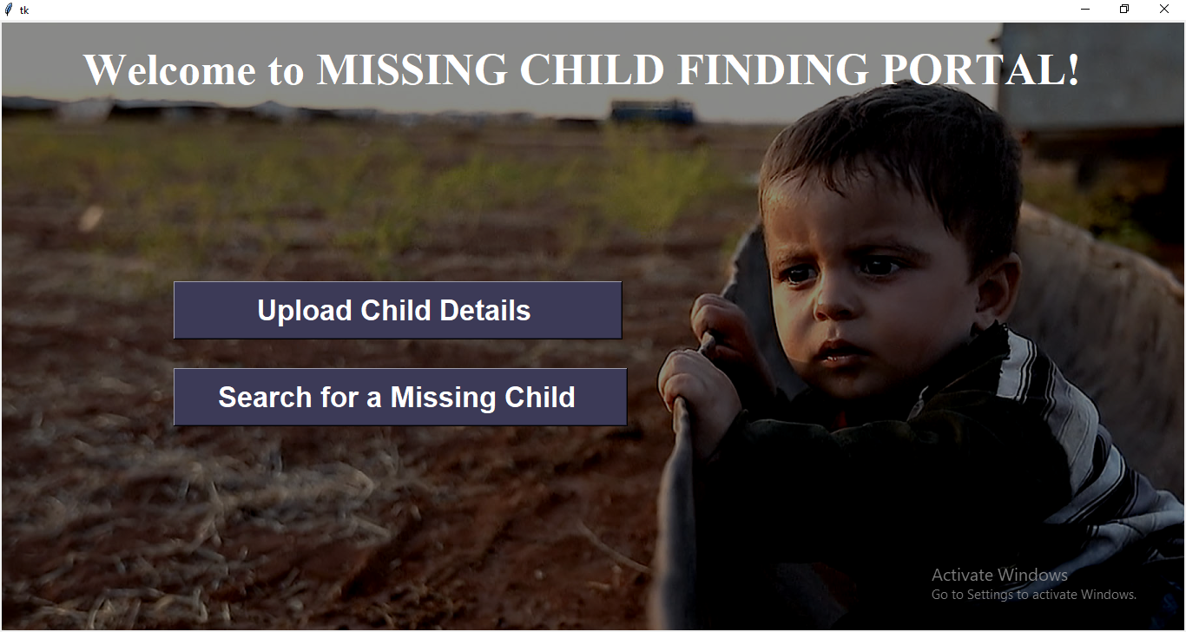

**Figure 5:** Welcome page of a missing child finding portal

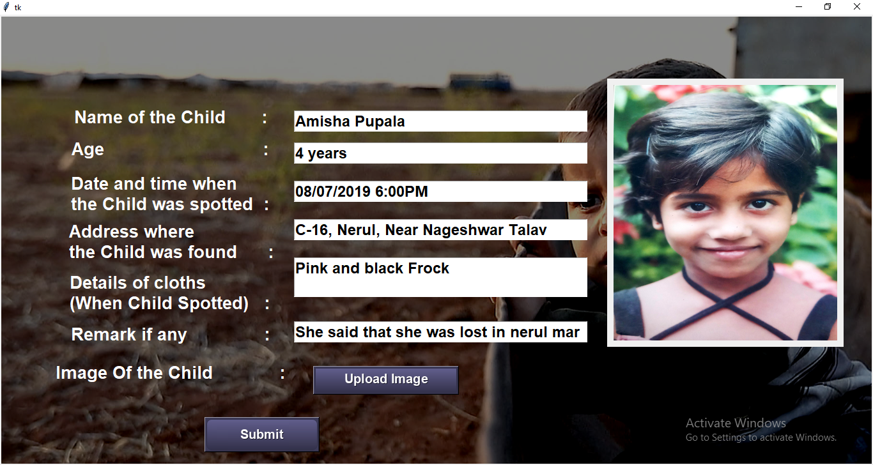

**Figure 5:** Page where the public can upload details of a suspicious or lost child

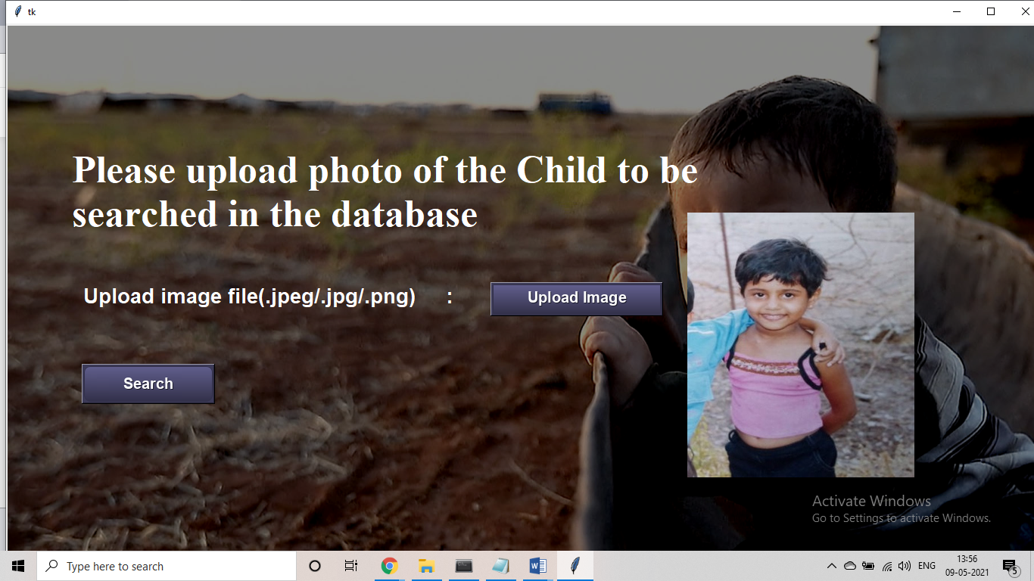

**Figure 5:** Page to search for a lost child using his/her photograph

#### 

**Figure 5:** The system requires some time to age progress the photograph and search in the database

#### 

**Figure 5:** Details of the child found in the database

Extracted Age Progressed Images

Extracted Age Progressed Images

Input Images

Input Images

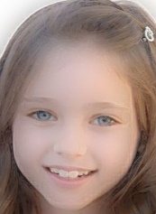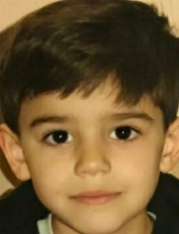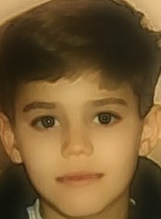

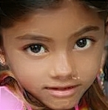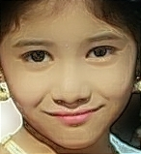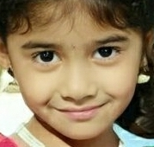

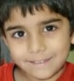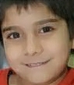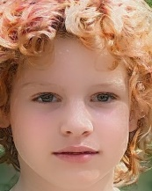

****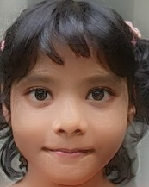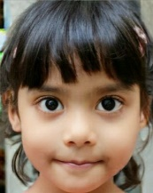

**Fig- Retrieved Age progressed images of the proposed system**

**Performance of face recognition algorithm was evaluated on child dataset before and after age progressing the child images. The Age cGAN model was trained on the IMBD Wiki-Crop dataset. The IMDB Wiki-Crop Dataset contains more than 400k images with different age groups ranging from 0-100 years. We have first filtered that dataset and have just used images from age group 0-15 years to train the model.**

Based on their experiments, the following conclusions are derived:

**1.**The accuracy of face recognition algorithm with the images of same age category is: train accuracy:87.38% and test accuracy is:81.07%

**2. The**Accuracy of face recognition algorithm with images if different age category: 44.76%

**3. The**Accuracy of FaceNet algorithm with images of different age category after age progressing images using Age-cGAN algorithm: 47.32%

|  |  |  |
| --- | --- | --- |
| **Model** | **Age Category** | **Accuracy** |
| Face Recognition | Same | 81.07% |
| Face Recognition | Different | 44.76% |
| Face Recognition on Age Progressed images | Different | 47.32% |

# Based on the experiments, the following conclusions are derived:

# 1. The model is correctly recognizing the misaligned faces and images clicked in an uncontrolled environment like the change of expression, illumination, pose, change in lighting condition, and presence of noise.

# 2. Average decrease in the performance of face recognition is more than 40% due to age variation in the faces of the children.

# 3. Intra-person variations like expression and pose are degrading the performance of the system is similar to face aging. Also, large self-occlusion, blur, and misaligned faces are slightly degrading the performance of the model.

# Feature Aging Module For all the experiments, we stack two fully connected layers and set the output of each layer to be of the same d dimensionality as the ID encoder’s feature vector. We train the proposed framework for 200,000 iterations with a batch size of 64 and a learning rate of 0.0002 using Adam optimizer with parameters β1 = 0.5, β2 = 0.99. In all our experiments, k = 32. Implementations are provided in the supplementary material

# 

# 

|  |  |  |  |  |
| --- | --- | --- | --- | --- |
| Author | Method used | Dataset | Rank 1 recognition rate (%) | |
| Without aging | With aging |
| Florian Schroff, Dmitry Kalenichenko, and James Philbin[6] | FaceNet | CFA | 38.16% | 55.30% |
| Hao Wang, Yitong Wang, Zheng Zhou, Xing Ji, Dihong Gong, Jingchao Zhou, Zhifeng Li, and Wei Liu[7] | CosFace | ITWCC | 60.72% | 66.12% |
| Karl Ricanek Jr., Ph.D. Senior Member IEEE, Shivani Bhardwaj, & Michael Sodomsky[8] | Cognitec | ITWCC | - | 41.1% |
| Li et al | MFDA | FG-NET |  | 47.50 |
| Grigory Antipov, Moez Baccouche, Jean-Luc Dugelay[9] | C-GAN | MNIST | - | 47.5 |

# Fig Rank 1 identification accuracy for previous work with and without the proposed feature aging module.

# [6]Florian Schroff, Dmitry Kalenichenko, and James Philbin. Facenet: A unified embedding for face recognition and clustering. In CVPR, pages 815–823, 2015.

# [7] Hao Wang, Yitong Wang, Zheng Zhou, Xing Ji, Dihong Gong, Jingchao Zhou, Zhifeng Li, and Wei Liu. Cosface: Large margin cosine loss for deep face recognition. In CVPR, 2018

# Feature Aging Module For all the experiments, we stack two fully connected layers and set the output of each layer to be of the same d dimensionality as the ID encoder’s feature vector. We train the proposed framework for 200,000 iterations with a batch size of 64 and a learning rate of 0.0002 using Adam optimizer with parameters β1 = 0.5, β2 = 0.99. In all our experiments, k = 32. Implementations are provided in the supplementary material

# [8] Karl Ricanek Jr., Ph.D. Senior Member IEEE, Shivani Bhardwaj, & Michael Sodomsky “A Review of Face Recognition against Longitudinal Child Faces”

# [9] FACE AGING WITH CONDITIONAL GENERATIVE ADVERSARIAL NETWORKS Grigory Antipov, Moez Baccouche, Jean-Luc Dugelay

# Limitations:

* Training of the deep learning model which requires a large dataset remains a challenge when training with a small dataset hence accuracy is compromised.
* The age-progressed images get blurred which eventually affects the performance of the model.
* The performance of the face recognition model heavily depends on the accuracy of age-progressed images which are obtained.
* Due to the long duration of code execution and heaviness of the model we have trained the model for 300 epochs due to which the performance of the model is compromised

# Suggested Solutions:

* As face aging depends on various other factors other than aging, it is required to consider all the other factors like having a single face aging database with correct demographic details and a lot of images of the child of various age groups is need of the hour for better accuracy of the face aging model.
* The model age progresses the images of the child to just one age group, this can further be improved in the future by using a bigger dataset and categorizing the images in the dataset in various required age groups.
* The Age progression model should be trained for at least 500 epochs for getting better accuracy for age-progressed images.

# Chapter 7

**Conclusion and Future Work**

#### Conclusion

In this work, a system is proposed for an age-invariant face recognition system for finding missing children. This system reduces the manual work of scanning through all the photographs of the lost children to find a match. We have tried to solve the problem of age variation by age progressing the images of the child using the Aging cGAN deep learning algorithm. The model improves the performance of the FaceNet model which we have used for face recognition from 44.76% to 47.32%. These results suggest that age progressing the faces of the children before face recognition enhances the ability of the system to identify the lost children who are possible victims of child abduction and trafficking. This will be beneficial for solving cases of untraced missing children and thus will help to reduce the increasing number of missing child cases.

#### Future Work

Generative approaches are found effective in facial form modeling, whereas, age invariant sig- natures are effectively extracted by discriminative strategies. Hence, a joint approach of world and native options might lead to higher performance because the human cognitive process is an integration of each approach. Recently, it’s been unconcealed that 3D facial image options square measure even additional reliability than blood profile for distinguishing age. Also, ag- ing introduces facial deformations in 3D space, so developing generative still as discriminative

strategies supported 3D face models need to be explored additional. Facial aging is stricken by numerous intrinsic still as alien factors, however, their qualitative analysis is missing. addition- ally, analysis of the impact of gender and race is additionally a prominent future direction within the development of a strong face recognition system. Therefore, coming up with strong age in- variant options and corresponding generalizable matching framework effective across aging and non-aging situations each may be a viable future direction.

**References**

[ 1 ] S. Chandran, Pournami Balakrishnan, Byju Rajasekharan, Deepak N Nishakumari, K Devanand, P M Sasi, P. (2018). “Missing Child Identification System Using Deep Learning and Multiclass SVM”.

[ 2 ] Xin Jin, Shiming Ge, Chenggen Song, Xiaodong Li, Jicheng Lei, Chuanqiang Wu, and Haoyang Yu “Double-Blinded Finder: A Two-SidePrivacy-Preserving Approach for Finding Missing Children”(2020).

[ 3 ] Shun Lei Myat Oo, Aung Nway Oo University of Information Technology, Yangon, Myanmar “ Child Face Recognition with Deep Learning”(2019).

[ 4 ] Chang Shu School of Communication and Information Engineering,University of Elec- tronic Science and Technology of China Chengdu,China “Optimizing deep neural network structure for face recognition” (2017).

[ 5 ] Grigory Antipov, Moez Baccouche, Jean-Luc Dugelay ”Face Aging with Conditional Generative Adversarial Networks” (2017) arXiv:1702.01983v2

# Appendices

**Appendix A**

**Weekly Progress Report Project A**

**Appendix B Plagiarism Report**



# Acknowledgement

We take this opportunity to express my profound gratitude and deep regards to our guide **Mrs. Smita Bharne** for his/her exemplary guidance, monitoring and constant encouragement throughout the completion of this report. We truly grateful to his/her efforts to improve our un- derstanding towards various concepts and technical skills required in our project. The blessing, help and guidance given by him/her time to time shall carry us a long way in the journey of life on which we are about to embark.

We take this privilege to express our sincere thanks to **Dr. Mukesh D. Patil**, Principal, RAIT for providing the much necessary facilities. We are also thankful to **Dr. Leena Ragha**, Head of Department of Computer Engineering, Project Co-ordinator **Mrs. Smita Bharne** and Project Co-coordinator **Mrs. Bhavana Alte**, Department of Computer Engineering, RAIT, Nerul Navi Mumbai for their generous support.

Last but not the least we would also like to thank all those who have directly or indirectly helped us in completion of this thesis.

##### Ms. Amisha Mangesh Pupala Ms. Samruddhi Manohar Mokal Ms Neha Ananta Pandit